**Lab Exercise 10– Creating an AWS RDS Instance in**

**Terraform**

1. **Create a Terraform Directory:**

**mkdir Terraform-RDS cd Terraform-RDS**

1. **Create Terraform Configuration Files:**

Create a file named main.tf:

**# main.tf**

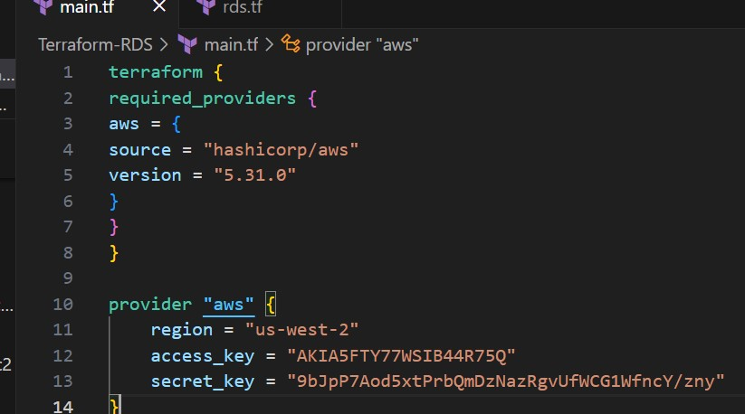

**#rds.tf**

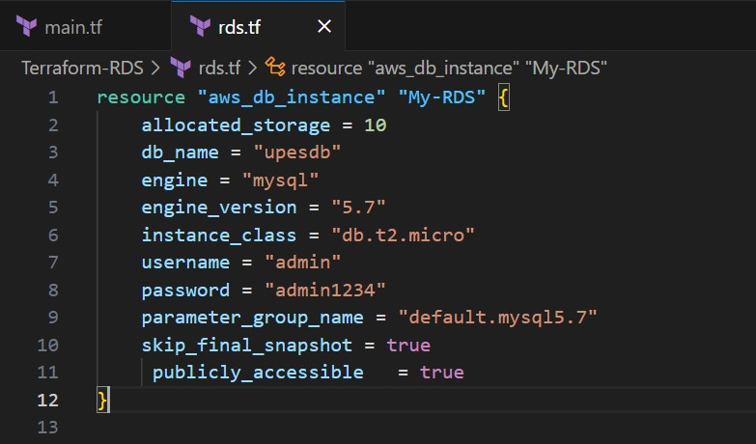

1. **Initialize and Apply:**

• Run the following Terraform commands to initialize and apply the configuration:

**terraform init terraform apply**

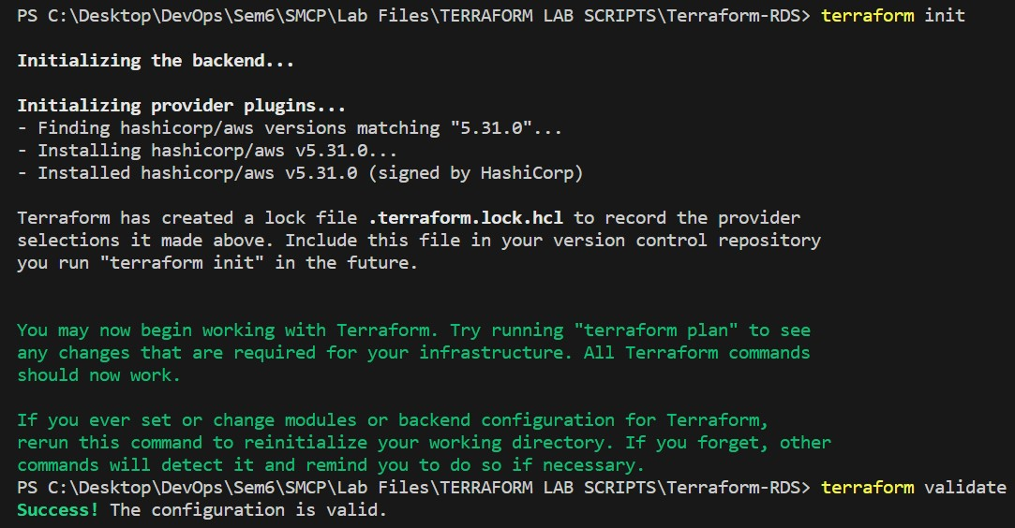

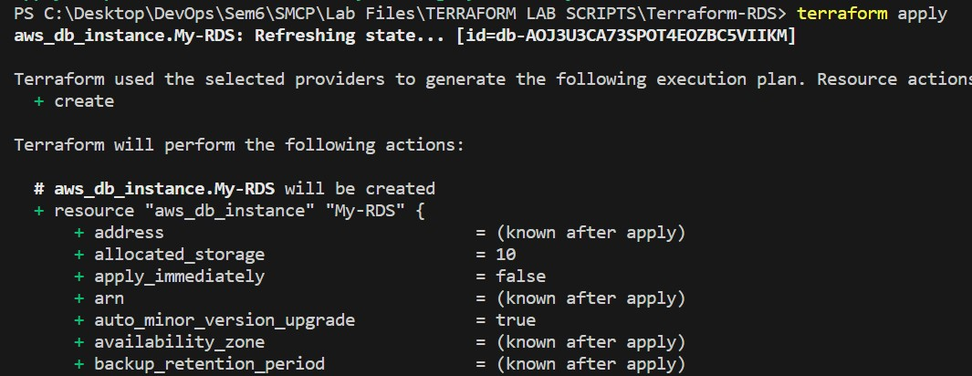

1. **Verify RDS Instance in AWS Console:**

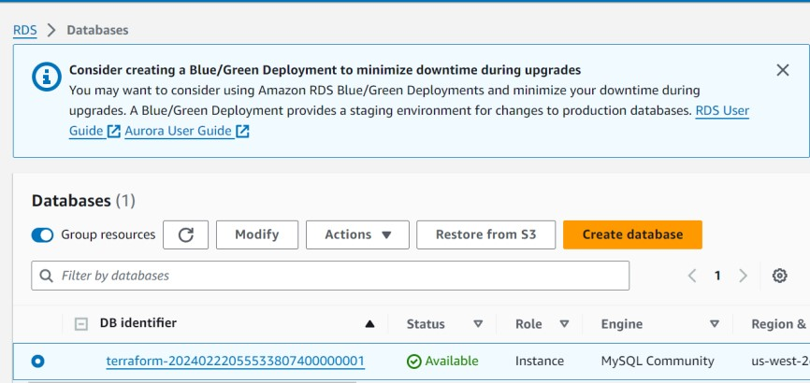

1. **Connect to MySQL Workbench**

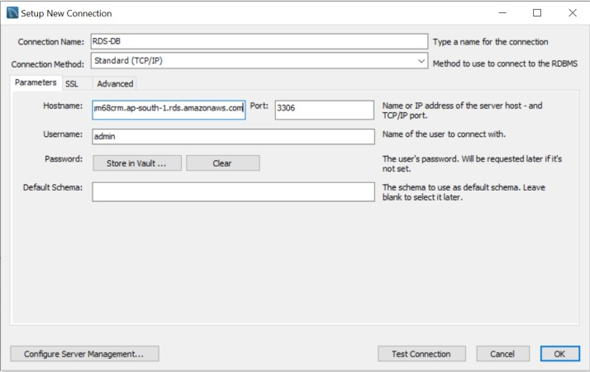

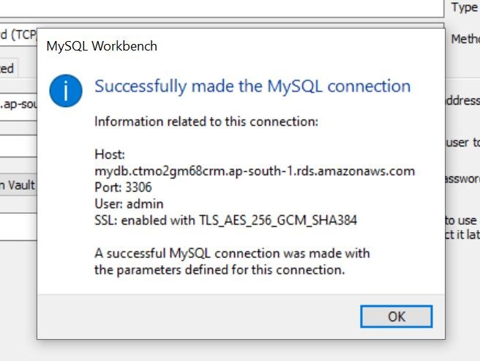

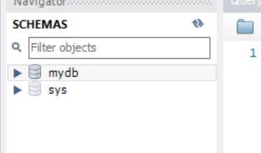

1. **Clean Up:**

**terraform destroy**

Confirm the destruction by typing yes.

